With Bertha Oliva

Coup de ’tat: 9 years later
Giorgio Trucchi 6/28/2018

On June 28, 2009 Honduras suffered a rupture of the constitutional order which has deepened in the following years. Bertha Oliva, Coordinator of the Committee of the Families of the Detained and Disappeared in Honduras (Cofadeh), with whom we share a long journey of work and resistance, remembers that day and analyzes the situation of the country nine years after that terrible morning.
Several hours after carrying out a non-binding popular referendum to measure the level of interest among the population in being consulted on the need for constitutional reforms or not, dozens of military, firing weapons, burst into the home of president Manuel Zelaya.
The leader was captured, forced to board a military plan and was taken to Costa Rica.
That morning marked a turning point in the recent history of Honduras.
The first coup de ‘tat of the century, orchestrated by national power groups with the support of the armed forces and approval from Washington, destroyed the institutionality of the country.
Nine years later, Honduras continues to be submerged in a deep political, economic, social and institutional crisis that is far from being resolved.
-What are your memories of that day?
-The coup de ‘tat marked my life and that of the Honduran people. It is impossible for me to forget the escalation of tensions that we experienced in the days prior to the rupture of constitutional order.
We perceived that the unequal confrontation between institutions could lead to something that would result in a regression of several decades. On June 27th, the tension was heavy.
Zelaya dismissed the head of the armed forces and the minister of Defense had resigned. Accompanied by the people, he had rescued the material for the popular consultation (Cuarta Urna) from the military base.
The social organizations were on alert, accompanying the process and defending the right of the people to express themselves.
That night I was very anxious.
-When did you find out what had happened?
-I got up early and turned on the radio. I heard loud voices and shots being fired. I said to myself: “It is a coup!” My family tried to calm me but I knew that I needed to be in the streets.
I began to receive calls. The first was from Carlos H. Reyes (member of the Latin-American Executive Committee of UITA and president of Stibys).
I went with my son and daughter to Cofadeh and then to the Casa Presidencial.
People were shocked. There was no electricity. No one knew where President Zelaya was.
The news media began a media siege to hide the truth and confuse national and international public opinion.
Several compañeros and compañeras decided to meet near the Casa Presidencial to prepare a communique. By this time there were a lot of people. This is where the National Front against the Coup was formed and then became the National Front of Popular Resistance (FNRP).
This spontaneous movement was comprised of a large number of social, popular, political and labor organizations. It was an incredible experience which later led to the formation of the Libre Party.
On June 29th, the brutal repression began against those of us who opposed the coup. Repression that far from lessening in intensity, has deepened and diversified in these 9 years.
Despite so much violence, repression and death the social movement has not, even for one instant, stopped demanding the return to constitutional order.
Nine years later
There is no democracy
-Honduras has not recovered institutional democracy…
-Sadly we are far from a return to normality. No one believes in the institutions.
The coup was executed by power groups and the oligarchical elites that control the country politically and economically.
The objective was to stop the opening of Honduras towards progressive governments and movements in Latin America and to take absolute control of the country, its institutions and resources.
What we see today is the continuation of the 2009 coup de ’tat in which the national elites, transnational capital and corrupt policies carry forward the same project of dispossession and looting that has destroyed institutionality.
In order to achieve its objectives, this power structure imposes a neoliberal extractivist model, criminalization and judicial persecution of protest, the use and abuse the power of the media, impunity, militarization of territories and populism to weaken protest.
-How can this situation be reversed?
-The country has to be reconstructed through the organization of the people of Honduras demanding the restitution of rights that have been lost.
The best book is written in the streets with the experience and the wisdom of the people.
An example is the work that we are carrying out with the Convergence against Continuism. And there are other spaces that are focused on this objective.
Today, more than ever, it is necessary to re- encounter ourselves, re-organize ourselves and return to the streets.

Giorgio Trucchi
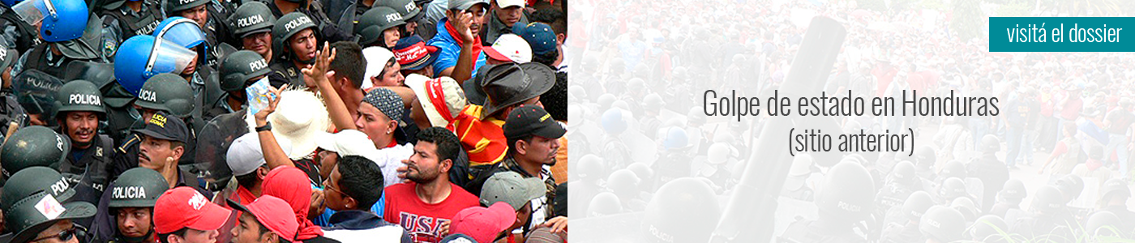

http://defensoresenlinea.com/golpe-civico-militar-nueve-anos-despues/

